17 September 2024 postcard

Tuesday morning, we set out as usual toward toward lunch and our day's excursion—this time to the Jacquemart-André museum on Boulevard Hausmann. It's a favorite of ours from years past, but this year it was also showing "Masterpieces from the Borghese Collections." It also has one of the most beautiful lunch/tea rooms in Paris. This year it's under new management (it operates independently of the museum, so you can go here to eat even if you don't pay admission to the museum), but some of our old favorites were still on the menu. The J-A is usually a pretty quiet place, but boy, has something changed! Maybe it's just the Borghese exhibition, but the place was suddenly teeming, mostly with French speakers.

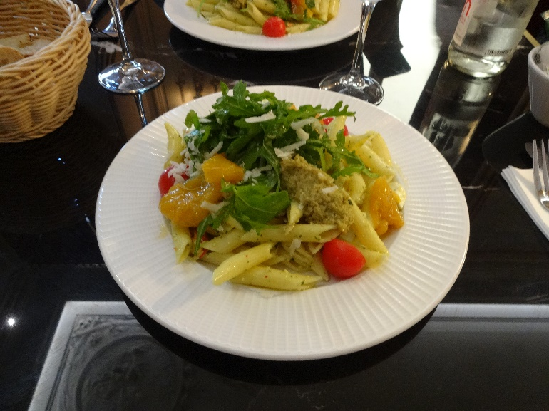People were lined up waiting to get into the restaurant, so we asked how long the wait was—maybe half an hour, we were told. So we joined the line, and after half an hour had advanced maybe a quarter of the length of the line, and that was mostly the result of folks ahead of us giving up and leaving. Finally, the log-jam broke, as people who showed up at opening time finally left, and we were seated by 1 pm, still in plenty of time for our 2 pm entry time.

We both chose the salad Bellini, followed by David's beloved fromage blanc with coulis de fruits rouges.

We did a quick turn through the permanent collection, which we've visited many times before, pausing to look for a little while to look again at Nattier's portrait of young Marie-François-Renée (known as Mathilde) de Carbonnel-Canisy , Marquise d'Antin (age 14), which hangs in our living room in poster form. (She became a marquise by marriage, at age 12, to a 28-year-old titled naval officer and was widowed at 16.)

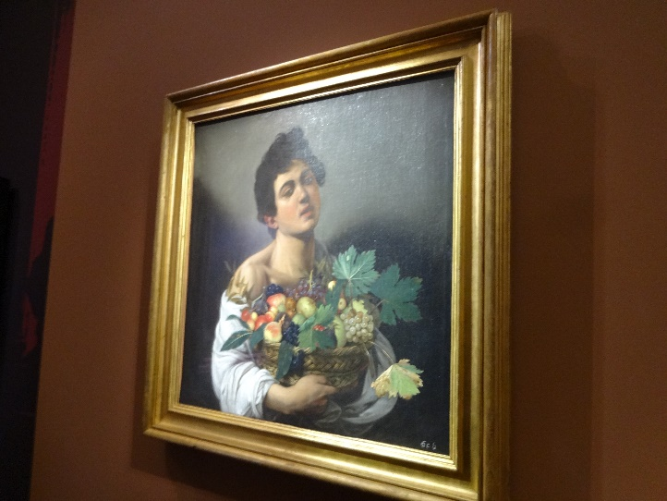*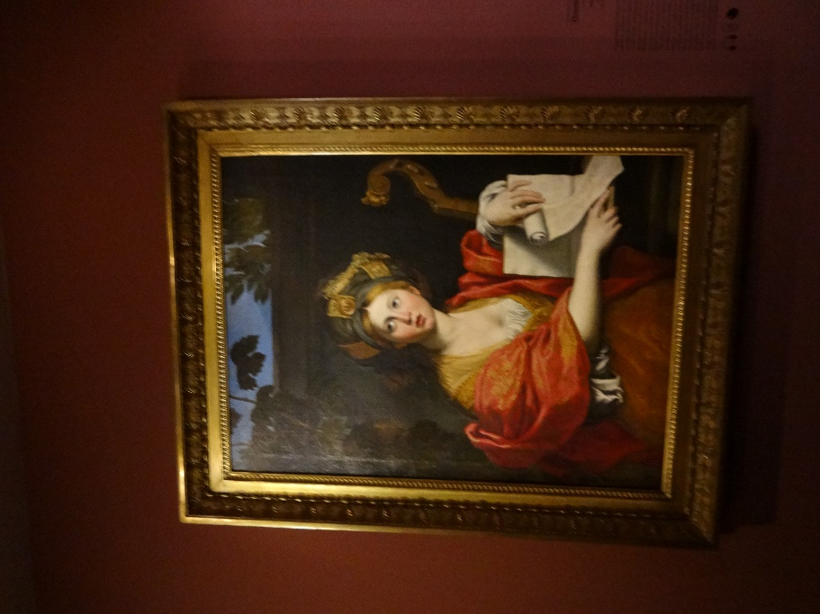*The Borghese items were pretty spectacular, covering most of the famous Italian painters of the time when it was accumulated. These are the two works that were featured in all the advertising (on the sides of buses, in the metro, etc.), by Caravaggio (left) and Dominiquin (right).

Tuesday was our last full day in Paris, so our dinner reservations were at a nearby branch of Chez Papa, a chain serving southwestern French food that we discovered last year. I chose it because at the time, I assumed we would have to leave at the crack of dawn Wednesday to catch our flight to Italy, and it's an informal sort of place where we could eat early. Suprisingly though that flight has been rescheduled by a *lot*. Rather than 1:50 pm, the most recent we heard, it now leaves at 3:50 pm! That explains why the Tauck people sent us an email saying they expected us at the Milan airport so much later than I thought we would be arriving.

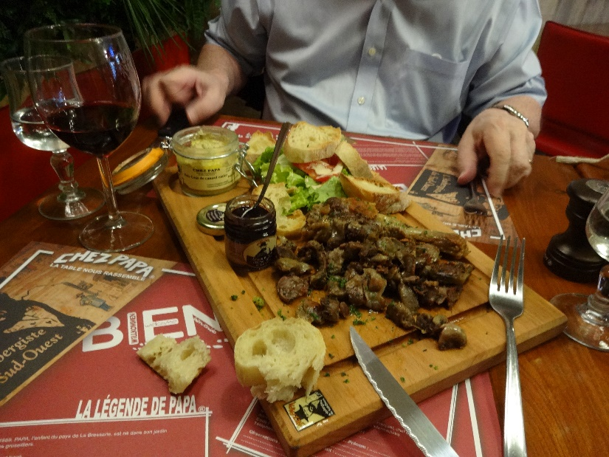Here's our starter, which we split. David ate most of the foie gras in the little glass canning jar, I ate most of the heap of confit gizards in the foreground, and we split the confit duck leg you can barely see just this side of the salad.

*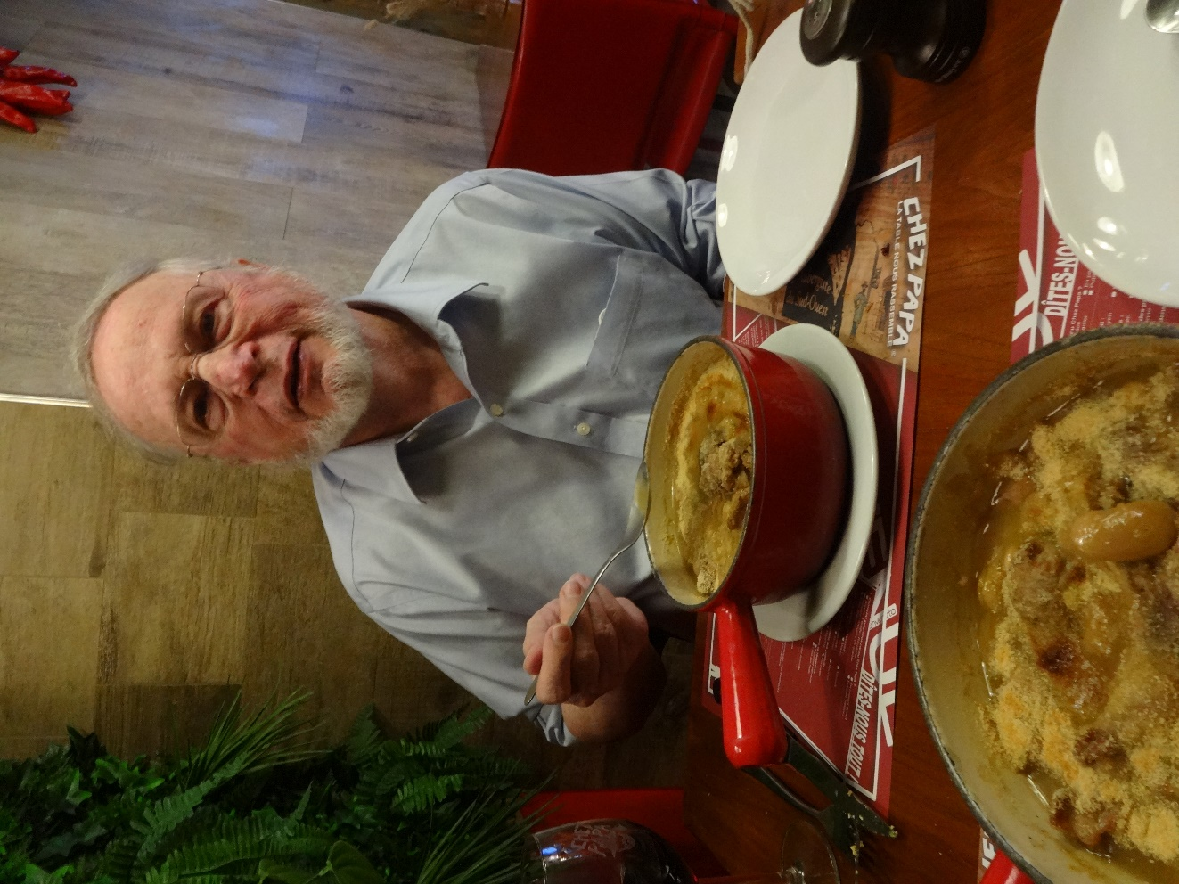*And here's our main course. We each ordered a cassoulet, since the waiter assured us it wasn't large enough to share. Right. Half a gallon each of duck, sausage, giant Tarb beans, in a sauce so rich it made your lips sticky. Scrumptious, but we couldn't come near finishing it.

Note, at the very bottom of the photo, just to the left of center, the single Tarb bean I have fished out and laid on the surface so you can see how large they are. Best stewing beans in the world.

Wednesday, off to Italy!